**NAME: Vishal Shashikant Salvi**

**UID: 2019230069**

**CLASS: TE COMPS**

**BATCH: C**

CEL 51, DCCN, Monsoon 2020

# Lab 6: Subnet and Router Configuration

## Topology Diagram

## 

## Addressing Table

|  |  |  |  |  |
| --- | --- | --- | --- | --- |
| **Device** | **Interface** | **IP Address** | **Subnet Mask** | **Default Gateway** |
| **R1** | **Fa0/0** | **192.168.1.65** | **255.255.255.192** | **N/A** |
| **S0/0/0** | **192.168.1.129** | **255.255.255.192** | **N/A** |
| **R2** | **Fa0/0** | **192.168.1.193** | **255.255.255.192** | **N/A** |
| **S0/0/0** | **192.168.1.190** | **255.255.255.192** | **N/A** |
| **PC1** | **NIC** | **192.168.1.126** | **255.255.255.192** | **192.168.1.65** |
| **PC2** | **NIC** | **192.168.1.254** | **255.255.255.192** | **192.168.1.193** |

## Learning Objectives

Upon completion of this lab, you will be able to:

* Subnet an address space given requirements.
* Assign appropriate addresses to interfaces and document.
* Configure and activate Serial and FastEthernet interfaces.
* Test and verify configurations.
* Reflect upon and document the network implementation.

## Scenario

In this lab activity, you will design and apply an IP addressing scheme for the topology shown in the Topology Diagram. You will be given one address block that you must subnet to provide a logical addressing scheme for the network. The routers will then be ready for interface address configuration according to your IP addressing scheme. When the configuration is complete, verify that the network is working properly.

Task 1: Subnet the Address Space.

Step 1: Examine the network requirements.

You have been given the 192.168.1.0/24 address space to use in your network design. The network consists of the following segments:

* The network connected to router R1 will require enough IP addresses to support 15 hosts.
* The network connected to router R2 will require enough IP addresses to support 30 hosts.
* The link between router R1 and router R2 will require IP addresses at each end of the link.

Step 2: Consider the following questions when creating your network design.

**How many subnets are needed for this network?**

3 subnets are needed for this network

1. For network connected to router R1

2. For network connected to router R2

3. For link between router R1 and router R2

**What is the subnet mask for this network in dotted decimal format?**

The given address block is 192.168.1.0/24

Network: 11000000.10101000.00000001.00000000

Subnet mask: 11111111.11111111.11111111.00000000

The number of usable host IPs = 2n – 2 = 28 – 2 = 254

We need 3 subnets and if we borrow 2 bits from host portion, we will get 2n subnets (n is no. of bits borrowed), i.e. 22 =4 subnets which are enough.

Hence subnet mask will be: 11111111.11111111.11111111.11000000

255.255.255.192

**What is the subnet mask for the network in slash format?**

The subnet mask for the network in slash format is the number of ones in the subnet mask written in dot separated format Hence, subnet mask for the network in slash format is /26

**How many usable hosts are there per subnet?**

2^6 – 2 = 62

Step 3: Assign sub-network addresses to the Topology Diagram.

1. Assign subnet 1 to the network attached to R1.

Subnet 1: 192.168.1.64

Network ID: 192.168.1.64/26

1st usable IP: 192.168.1.65/26

Last usable IP: 192.168.1.126/26

Broadcast IP: 192.168.1.127/26

1. Assign subnet 2 to the link between R1 and R2.

Subnet 2: 192.168.1.128

Network ID: 192.168.1.128/26

1st usable IP: 192.168.1.129/26

Last usable IP: 192.168.1.190/26

Broadcast IP: 192.168.1.191/26

1. Assign subnet 3 to the network attached to R2.

Subnet 2: 192.168.1.192

Network ID: 192.168.1.192/26

1st usable IP: 192.168.1.193/26

Last used IP: 192.168.1.254/26

Broadcast IP: 192.168.1.255/26

Task 2: Determine Interface Addresses.

Step 1: Assign appropriate addresses to the device interfaces.

1. Assign the first valid host address in subnet 1 to the LAN interface on R1.

**192.168.1.65**

1. Assign the last valid host address in subnet 1 to PC1.

**192.168.1.126**

1. Assign the first valid host address in subnet 2 to the WAN interface on R1.

**192.168.1.129**

1. Assign the last valid host address in subnet 2 to the WAN interface on R2.

**192.168.1.190**

1. Assign the first valid host address in subnet 3 to the LAN interface of R2.

**192.168.1.193**

1. Assign the last valid host address in subnet 3 to PC2.

**192.168.1.254**

Step 2: Document the addresses to be used in the table provide under the Topology Diagram.

Task 3: Configure the Serial and FastEthernet Addresses.

Select 2 PC’s, 2 1841 Routers and a Switch and arrange them.

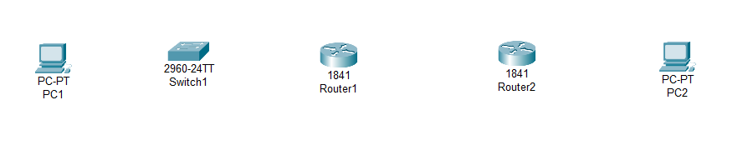

Click on Router Router1 and Physical.

Add a WIC-2T card for serial connection.

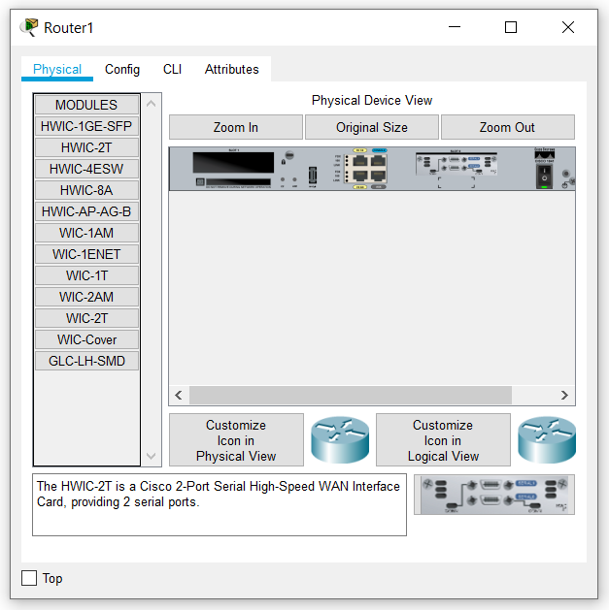

Click on Router Router2 and Physical.

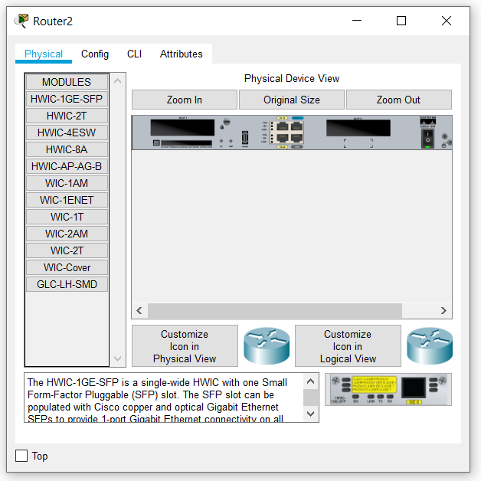

Add a WIC-2T card for serial connection.

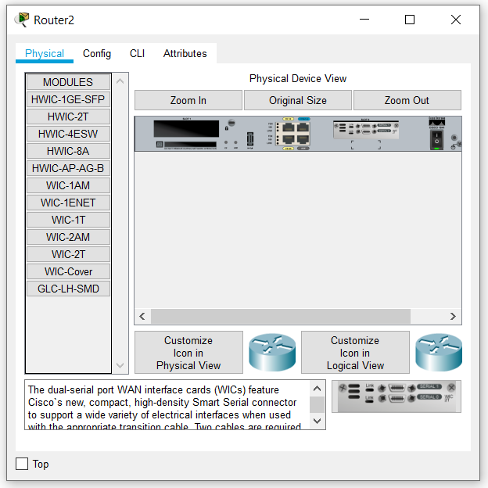

Connect Router R1 and Router R2 with Serial DCE at Serial 0/0/0 of both Routers.

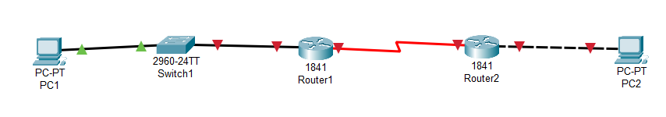

**Topology:**

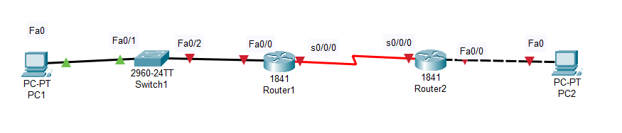

Step 1: Configure the router interfaces.

Configure the interfaces on the R1 and R2 routers with the IP addresses from your network design. Please note, to complete the activity in Packet Tracer you will be using the Config Tab. When you have finished, be sure to save the running configuration to the NVRAM of the router.

Configuration for R1: Set the IP Address & Subnet mask and change the port status to on at FastEthernet0/0.

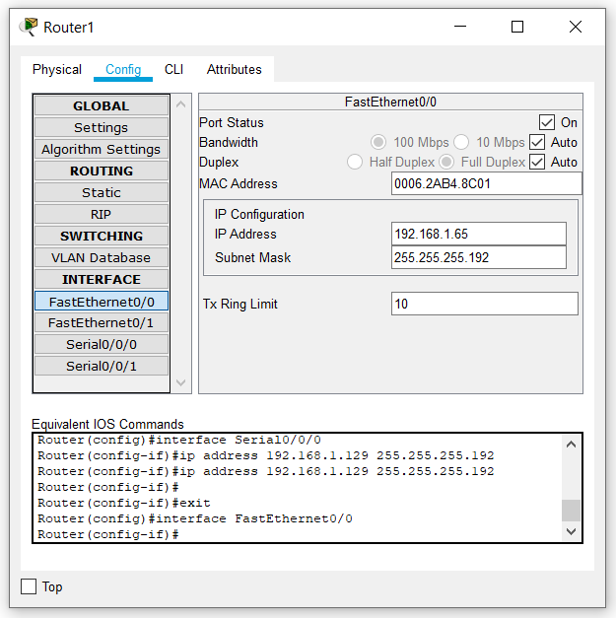

Set the IP Address & Subnet mask and change the port status to on at Serial0/0/0

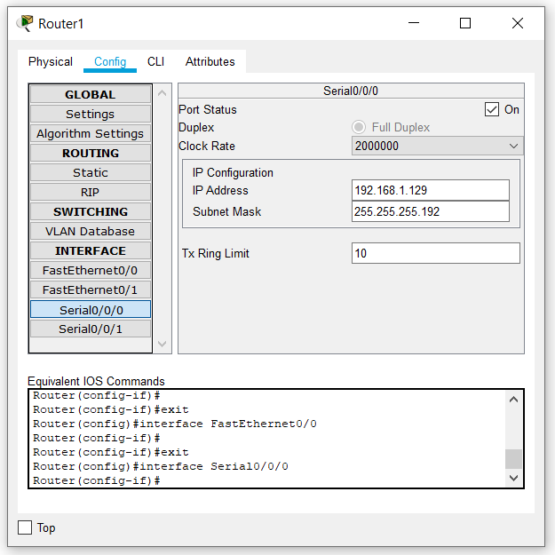

Save Running Configuration to NVRAM by clicking on save button in settings of R1 config.

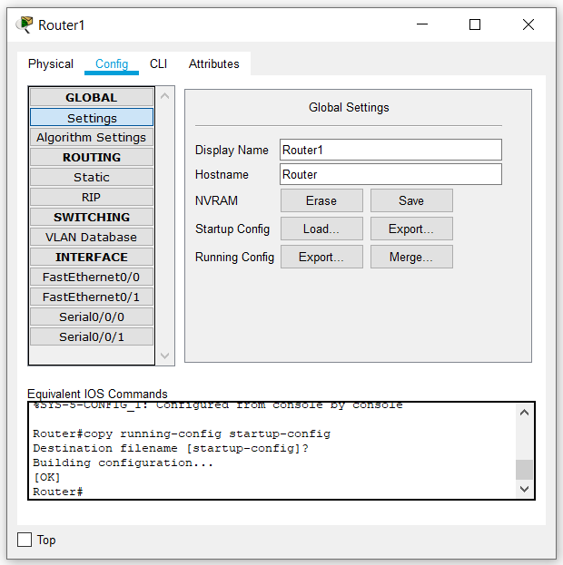

Configuration for R2: Set the IP Address & Subnet mask and change the port status to on at FastEthernet0/0.

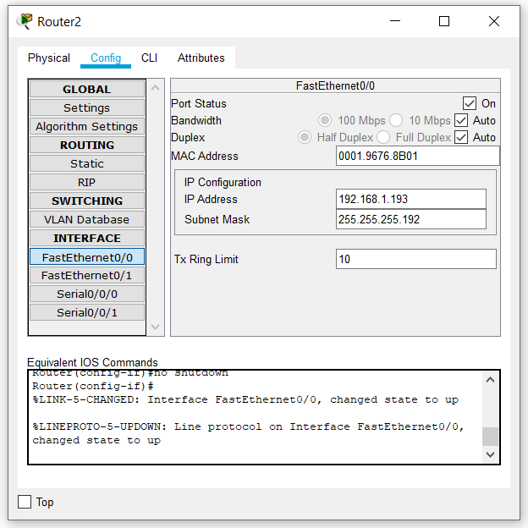

Set the IP Address & Subnet mask and change the port status to on at Serial0/0/0

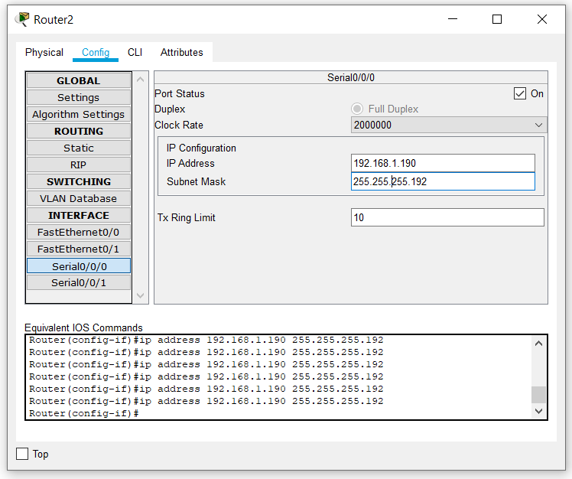

Save Running Configuration to NVRAM by clicking on save button in settings of R1 config.

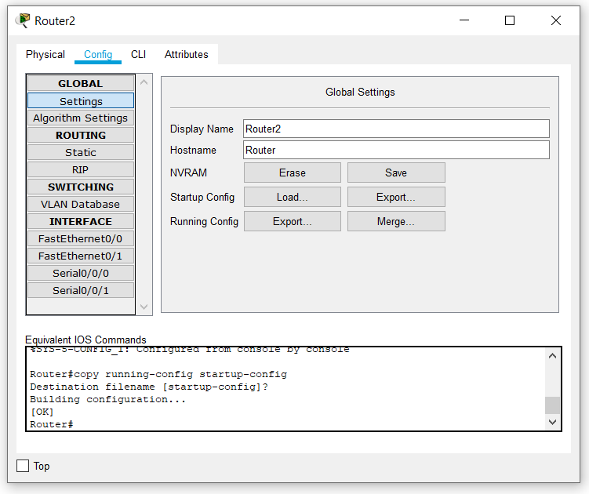

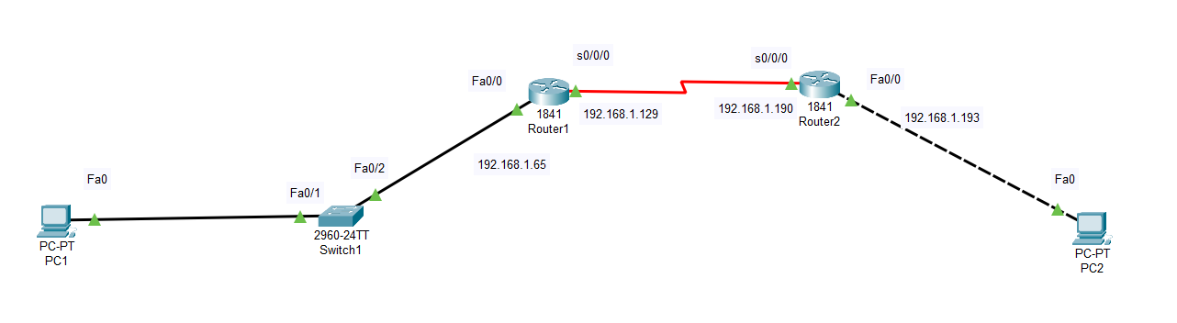

Step 2: Configure the PC interfaces.

Configure the Ethernet interfaces of PC1 and PC2 with the IP addresses and default gateways from your network design.

PC1 configuration:

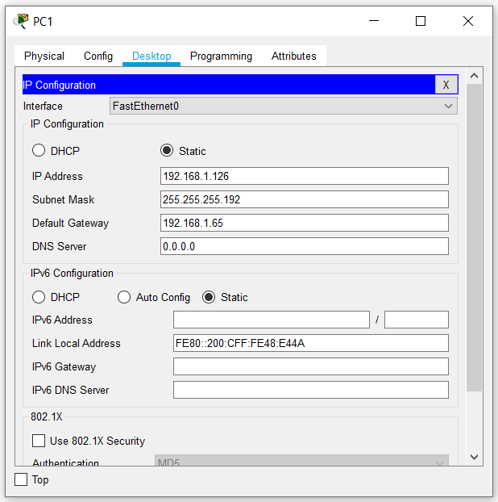

PC2 configuration:

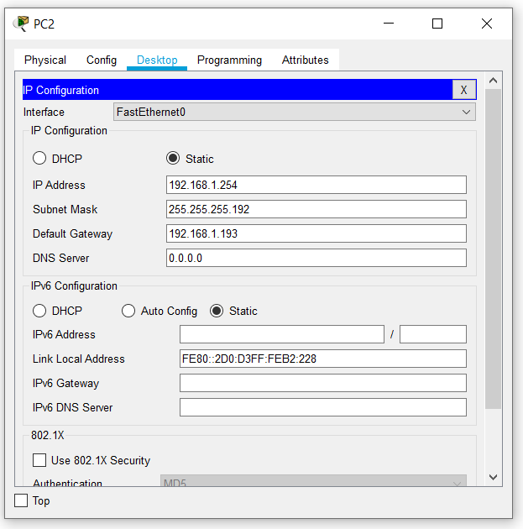

Switch1 Configuration

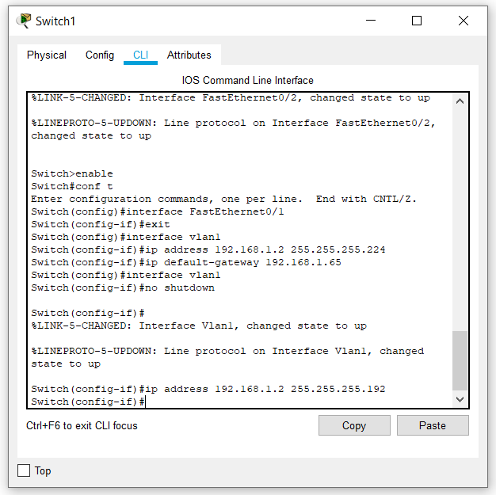

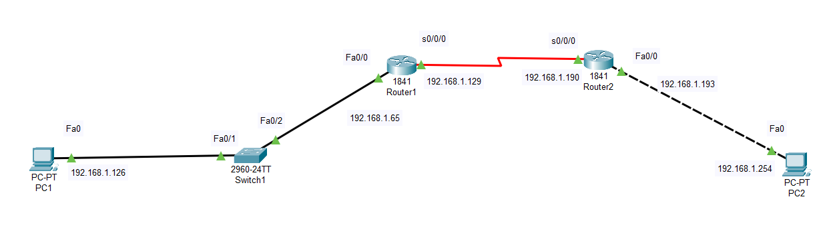

Task 4: Verify the Configurations.

Answer the following questions to verify that the network is operating as expected.

From the host attached to R1, is it possible to ping the default gateway?

**Yes**

Successful ping from PC1 to default gateway i.e. Fa0/0 of R1

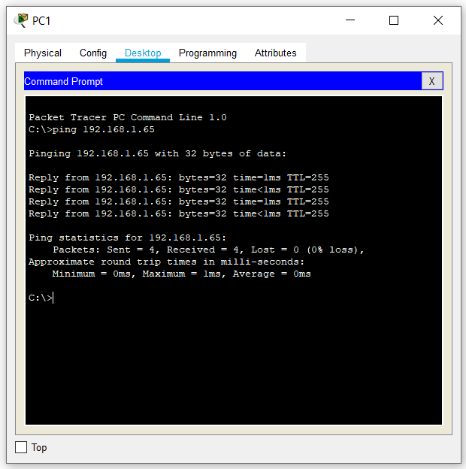

From the host attached to R2, is it possible to ping the default gateway?

**Yes**

Successful ping from PC2 to default gateway i.e. Fa0/0 of R2

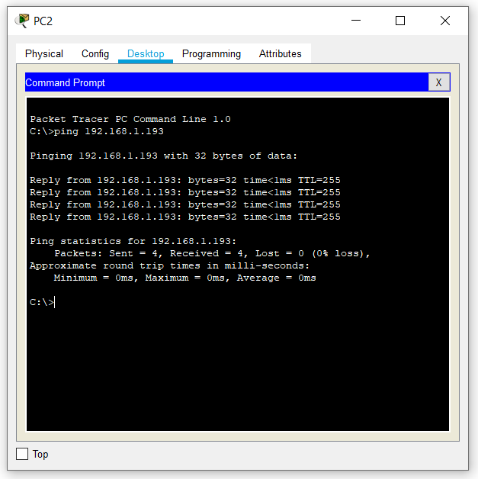

From the router R1, is it possible to ping the Serial 0/0/0 interface of R2?

**Yes**

Successful ping from R1 to port S0/0/0 of Router2

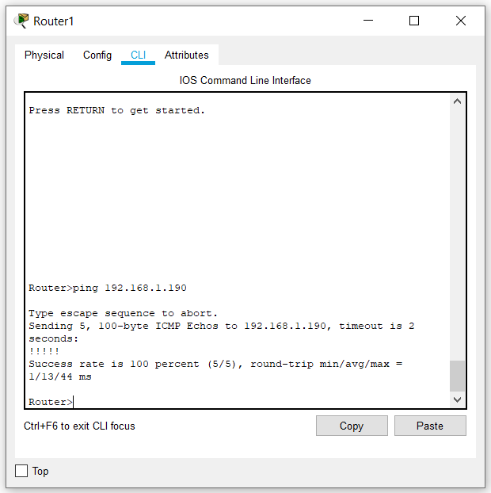

From the router R2, is it possible to ping the Serial 0/0/0 interface of R1?

**Yes**

Successful ping from R2 to port S0/0/0 of R1

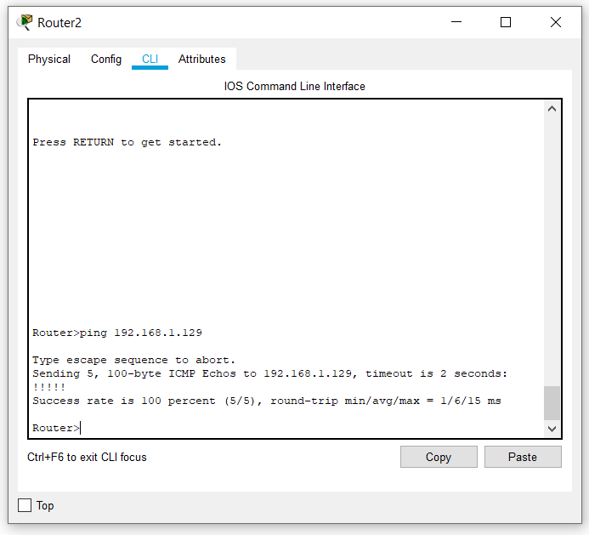

The answer to the above questions should be **yes**. If any of the above pings failed, check your physical connections and configurations.

Task 5: Reflection

Are there any devices on the network that cannot ping each other?

**Yes**, there are devices on the network that cannot ping each other.

• PC1 cannot ping FastEthernet port of Router2 and PC2

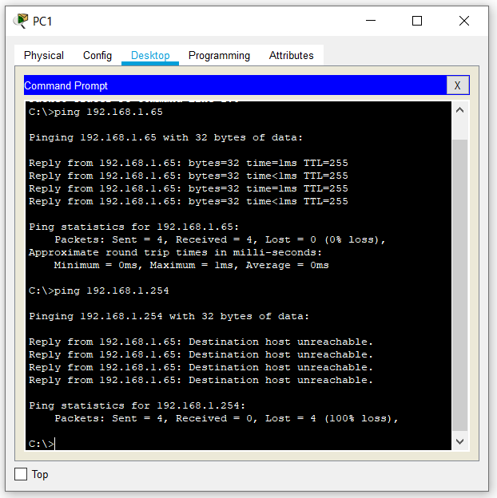

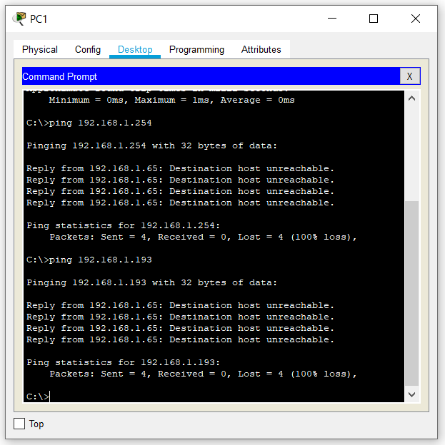

PC2 cannot ping FastEthernet port of Router1 and PC1

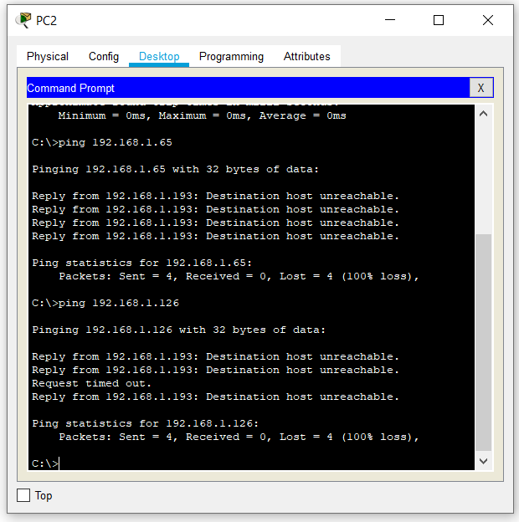

What is missing from the network that is preventing communication between these devices?

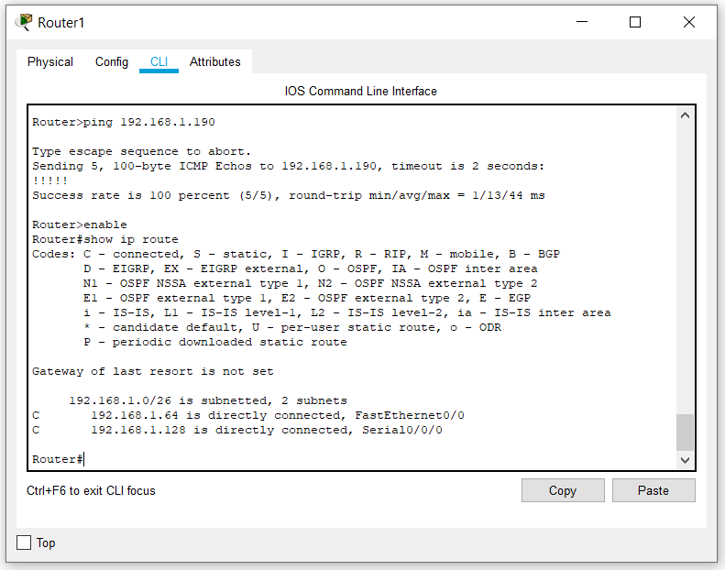

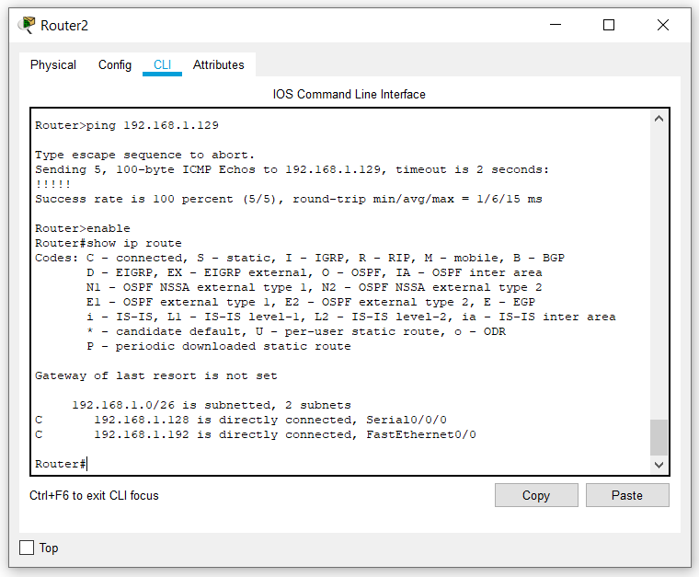

From the above routing table, we can see that the routers in our network only have the addresses of devices which are directly connected to its interfaces in their routing table. Hence static or dynamic routing is not present. Therefore, over here we cannot ping devices on another subnet.

**Conclusion:**

In this experiment I learned about subnetting a given address space and assigning subnets to various networks and router configuration.